Chapter 3 Problem Set ITEC 4200 Oracle

Include the following comments at the top:
-- Your Name
-- Date

For each of the following queries, type an SQL statement into SQL Developer. Save each query in the format ch3px, where x is the problem number, e.g. ch3p1, ch3p2, etc.
Make sure your answers are easy to read and in order. Put SELECT, FROM, and WHERE clauses on separate lines. Capitalize all keywords, use lowercase for tables and columns. Label all column headings as shown in the results.

- Display the name and salary for all employees whose salary is not in the range of $2000 - $9500. Sort in descending order by salary. (the first few rows are shown.)
Employee Salary
------------------------- ----------
King 24000
Kochhar 17000
De Haan 17000
Russell 14000
Etc…

- Display the last name and date of birth for all students born between May 1st and September 30th 1985 inclusive. Order by the last name.
Student Date of Birth
------------------------------ -------------
Miller 14-JUL-85
Umato 19-AUG-85
- List the building code, room number and capacity for all locations that have capacity over 30 and are on the first floor. Order by capacity.
BLDG_CODE ROOM CAPACITY
---------- ------ ----------
CR 103 35
CR 105 35
BUS 105 42
CR 101 150
- Display the name and job title of all managers who do not have a commission. Order by last name (first few rows shown):

Name Job Title
------------------------- ----------
Fripp ST_MAN
Greenberg FI_MGR
Hartstein MK_MAN
Higgins AC_MGR
Kaufling ST_MAN

- List the call id and course name for all courses that have C++ in the title. Order by Call_id.
Call ID Course Name
---------- -------------------------
CS 155 Programming in C++

- Display the name (concatenate the first name, middle initial, and last name), date of birth, and age for all students born in 1986. Show the age with two decimal places. Order by date of birth, as shown below: (Hint: Use the ROUND function)

Full Name Date of Birth Age
------------------------------ ------------- ---------
Amanda J. Mobley 24-SEP-86 27.94
Ruben R. Sanchez 20-NOV-86 27.79
Michael S. Connoly 04-DEC-86 7.75
- Write a script file to display the employee name and salary for all employees whose salary is between a given low and high salary. Prompt the user for the two salaries. Concatenate the name and job together, separated by a space and a comma, and order by the employee’s last name. Here are two sample runs. The first run uses the range 3500 - 4000:

Employees Salary
------------------------------------- ----------
Bell, SH_CLERK 4000
Chung, SH_CLERK 3800
Dilly, SH_CLERK 3600
Everett, SH_CLERK 3900
Ladwig, ST_CLERK 3600
Rajs, ST_CLERK 3500

This run uses the range 5000 – 6000:
Employees Salary
------------------------------------- ----------
Ernst, IT_PROG 6000
Fay, MK_REP 6000
Mourgos, ST_MAN 5800

- Write a script to display the department id, and then one other column (the name of the column is entered by the user). This same column is then also used in the ORDER BY clause to order the resulting rows. Restrict the rows to those that are greater than a certain department id (this number is also entered in by the user.) Make sure that the user is prompted to enter the column name ONLY ONCE using the double ampersand, and that it is “cleared out” after the run.

Two runs of the script are shown below:
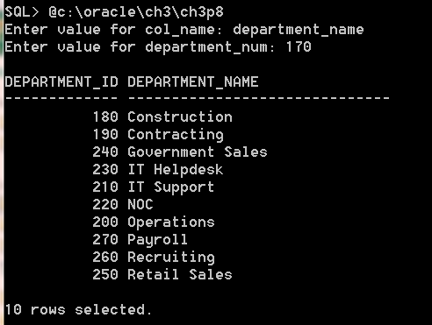

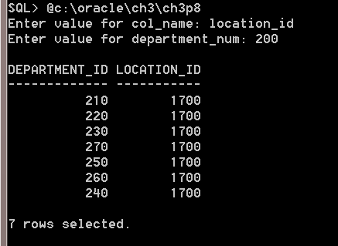

- Using the Animal Shelter schema, create a new problem using the features introduced in this chapter.

